Creating Your Own Exceptions
So far in this chapter we have been using built-it exception classes such as ZeroDivisionError, ValueError, TypeError, RuntimeError etc. Python also allows you to create new exception classes to cater you own specific needs. The BaseException class is the root of all exception classes in Python. The following figure shows exception class hierarchy in Python.
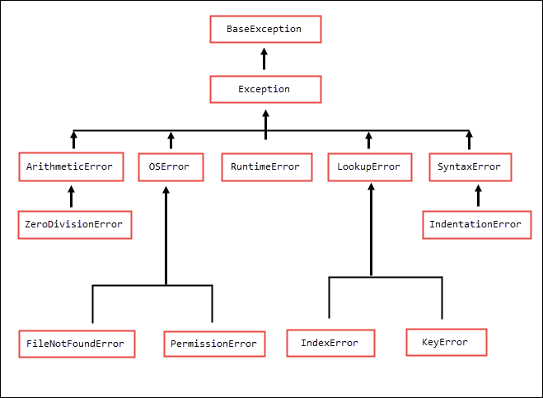
We can create our own exception class by deriving it from Exception built-in class. The following examples shows how to create a custom exception.
python101/Chapter-19/InvalidFactorialArgumentException.py
1  2  3  4  5  6  7 | class InvalidFactorialArgumentException(Exception):  def __init__(self, message):  super().__init__()  self.message = message  def __str__(self):  return self.message
python101/Chapter-19/factorialWithCustomException.py
1  2  3  4  5  6  7  8  9  10  11  12  13  14  15  16  17  18  19  20  21  22  23 | from InvalidFactorialArgumentException import *  def factorial(n):  if not isinstance(n, int):  raise InvalidFactorialArgumentException("Argument must be int")  if n < 0:  raise InvalidFactorialArgumentException("Argument must be >= 0")  f = 1  for i in range(n):  f *= n  n -= 1  return f  try:  print("Factorial of 4 is:", factorial(4))  print("Factorial of 12 is:", factorial("12"))  except InvalidFactorialArgumentException as e:  print("Error:", e)

